**Transient and steady state response analysis**

* **Transient Response:** which goes from the initial state to the final state.
* **Steady-State Response:** in which the system output behaves as t approaches infinity.

**Test signals:**

Unit Step: $r\left(t\right)=A$ $R\left(s\right)= \frac{A}{s}$

Ramp: $r\left(t\right)=At$ $R\left(s\right)= \frac{A}{s^{2}}$

Parabolic: $r\left(t\right)=At^{2}$ $R\left(s\right)=\frac{2A}{s^{3}}$

1. **First order systems:**

The closed-loop transfer function is $\frac{C(s)}{R(s)}=\frac{1}{Ts+1}$

1. **Unit-Step Response: $C \left(s\right)=\frac{1}{Ts+1}R \left(s\right) = \frac{1}{Ts+1} \frac{1}{s}$**

By partial fractions $C \left(s\right)=\frac{1}{s}-\frac{1}{s+(1/ T)} c\left(t\right)=1-e^{-t/T}, for t ≥ 0$

1. **Unit-Ramp Response: $C \left(s\right)=\frac{1}{Ts+1}R\left(s\right)= \frac{1}{Ts+1} \frac{1}{s^{2}}$**

By partial fractions $C \left(s\right)=\frac{1}{s^{2}}-\frac{T}{s}-\frac{1}{s+(1/ T)} c\left(t\right)=t-T-Te^{-t/T}, for t ≥ 0$

1. **Second order systems:**

The closed-loop transfer function

 $$\frac{C(s)}{R(s)}=\frac{ω_{n}^{2}}{s^{2}+2ξω_{n}s+ω_{n}^{2}}=\frac{ω_{n}^{2}}{(s+ξω_{n}s+jω_{d}) (s+ξω_{n}s-jω_{d})}$$

$ξ$ damping ratio

$ω_{n}$ undamped natural frequency

$σ=ξω_{n}$ damping factor

$ω_{d}=ω_{n}\sqrt{1-ξ^{2}}$ damped natural frequency

β = $\sqrt{1-ξ^{2}}$

θ = $\cos^{-1}ξ$

The behavior of the second-order system can be described in terms of ${, ω}_{n}$.

1. Undamped (Maginally) case: $ξ$ = 0 $\frac{C(s)}{R(s)}=\frac{ω_{n}^{2}}{(s^{2}+ω_{n}^{2})}$ $s_{1},s_{1}=±jω_{n}$
2. Underdamped case: 0 < $ξ$ < 1 $\frac{C(s)}{R(s)}=\frac{ω_{n}^{2}}{(s+ξω_{n}s+jω_{d}) (s+ξω_{n}s-jω_{d})}$ $s_{1},s_{1}=- σ±jω_{d}$
3. Critically damped case: $ξ$ = 1 $\frac{C(s)}{R(s)}=\frac{ω_{n}^{2}}{s^{2}+2ω_{n}s+ω_{n}^{2}}$ $s_{1},s_{1}=- ω_{n}$
4. Overdamped case: $ξ$ > 1 $\frac{C(s)}{R(s)}=\frac{ω_{n}^{2}}{(s+ξω_{n}s+ω_{d}) (s+ξω_{n}s-ω_{d})}$ $s_{1},s_{1}=- σ±ω_{d}$



Unit-step response curves of the system

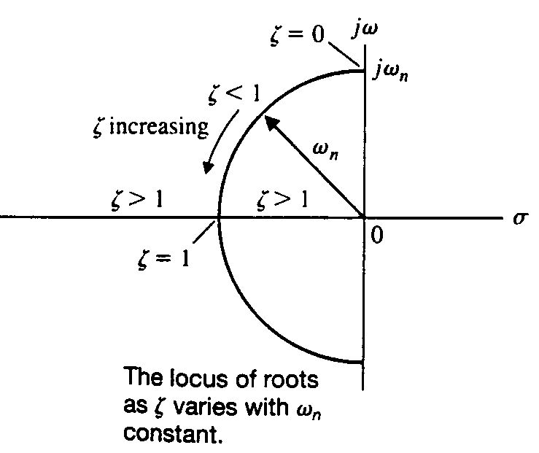

Definitions of Transient-Response Specifications:

* Delay time $T_{d}$: The time required for the response to reach half of its final value.
* Rise time $T_{r}$: The time required for the response to rise from
* 10% to 90 % of its final value for overdamped systems.
* 0 % to 100% of its final value for underdamped systems.
$$T_{r}=\frac{2.16ξ+0.6}{ω_{n}}$$

* Peak time $T_{p}$: The time required for the response to reach the first peak of the overshoot.
$$T_{p}=\frac{π}{ω_{n}\sqrt{1-ξ^{2}}}$$

* Maximum (percent) overshoot $M_{p}$:The maximum peak value of the response curve measured from unity
$$M_{p}=\frac{Mv-Fv}{Fv} P_{o}=\frac{Mv-Fv}{Fv}100\% P_{o}=100 e^{-ξπ/\sqrt{1-ξ^{2}}}$$

* Settling time ${ T}_{s}$: The time required for the response curve to reach and stay within a range about the final value of size percentage of the final value (2% or 5%).

For 𝝳=2 $\%$, $e^{-ξω_{n}T_{s}}< 0.02$ → $ξω_{n}T_{s}≅4$



$$T_{s}=\frac{4}{ξω_{n}}=4$$

Stability Analysis

Routh's Stability Criterion tells us whether or not there are unstable roots in a polynomial equation without actually solving for them.

Procedures for a control system:

1. Determine the characteristics equation q(s)



$\frac{C(s)}{R(s)}=\frac{k}{s\left(s^{2}+s+1\right)\left(s+2\right)+k}$ $q\left(s\right)=s\left(s^{2}+s+1\right)\left(s+2\right)+k q\left(s\right)=s^{4}+{3s}^{3}+{3s}^{2}+2s+k$

This means: If $\frac{C(s)}{R(s)}=\frac{B(s)}{A(s)}$ ∴ $q\left(s\right)= A\left(s\right)$

1. Write the polynomial in s in the following form: $q\left(s\right)= A\left(s\right)= a_{o}s^{n}+a_{1}s^{n-1}+…+a_{n-1}s^{o}+a_{n}$
2. Ensure that the coefficients are not zero or negative in the presence of at least one positive.
3. Arrange the coefficients of the polynomial in rows and columns according to the following pattern:

$s^{n} { a}_{o}{ a}_{2}{ a}_{4} ……$

$s^{n-1} a_{1}{ a}_{3}{ a}_{5} ……$

$s^{n-2} b_{1}{ b}_{2}{ b}_{3} ……$

$s^{n-3} c_{1}{ c}_{2}{ c}_{3} ……$

$…… …… …… …… ……$

$…… …… …… …… ……$

$s^{2} k_{1}{ k}_{2}$

$s^{1} l_{1}$

$s^{0} m_{1}$

$$b_{1}=\frac{ a_{1}a_{2}-a_{o}a_{3}}{a_{1}}{ b}_{2}=\frac{ a_{1}a_{4}-a_{o}a_{5}}{a_{1}}$$

$$c_{1}=\frac{ b_{1}a_{3}-a_{1}b_{2}}{b_{1}}{ c}_{2}=\frac{ b_{1}a_{5}-a_{1}b_{3}}{b_{1}}$$

1. The number of roots of the equation is equal to the number of changes in sign of the coefficients of the first column of the array, only the signs are needed.
2. Special Cases:
3. If a first term in any row is zero, but the remaining terms are not zero or there is no remaining term, then the zero term is replaced by a very small positive number ε and the rest of the array is evaluated.

* Example 1: $q\left(s\right)=s^{3}+{2s}^{2}+s+2$ → ${ s}^{3} 1 1$

$s^{2} 2 2$

$s^{1} 0≈ϵ$

$s^{0} 2$

If the sign of the coefficient above the zero ($ϵ$) is the same as that below it, it indicates that there are a pair of imaginary roots.

* Example 2: $q\left(s\right)=s^{3}-3s+2$ → ${ s}^{3} 1 -3$

One sign change $s^{2} 0≈ϵ 2$

$s^{1} -3-\frac{2}{ϵ}$

One sign change $s^{0} 2$

If the sign of the coefficient above the zero ($ϵ$) is opposite that below it, it indicates that there is one sign change.

1. If all the coefficients in any derived row are zero, we form an auxiliary polynomial with the coefficients of the last row and by using the coefficients of the derivative of this polynomial in the next row.

* Example 1: $q\left(s\right)=s^{5}+2s^{4}+24s^{3}+{48s}^{2}-25s-50$

$${ s}^{5} 1 24 -25$$

Auxiliary polynomial $P\left(s\right) { s}^{4} 2 48 -50$

${ s}^{3} 0 0$

$P\left(s\right)=2s^{4}++{48s}^{2}-50$ indicates that there are two pairs of roots of equal magnitude and opposite sign.

The terms in the ${ s}^{3}$ row are replaced by the coefficients of the derivative of $P\left(s\right)$

$$\frac{dP(s)}{ds}=8s^{3}+96s$$

$${ s}^{5} 1 24 -25$$

${ s}^{4} 2 48 -50$

$s^{3} 8 96$

$s^{2} 24 -50$

$s^{1} 112.7$

$s^{0} -50$

This indicates that there are roots of equal magnitude lying radially opposite in the s plane, two real roots with equal magnitudes and opposite signs and/or two conjugate imaginary roots.

1. Relative Stability Analysis: we substitute s = $\dot{s}$- $σ$ ( $σ$ = constant) into the characteristic equation, write the polynomial in terms of $\dot{s}$ and apply Routh's stability criterion to the new polynomial. This test reveals the number of roots that lie to the right of the vertical line s = - $σ$.
2. Determine the range of K for stability. For the closed-loop transfer function $\frac{C(s)}{R(s)}=\frac{k}{s\left(s^{2}+s+1\right)\left(s+2\right)+k}$

$$q\left(s\right)=s\left(s^{2}+s+1\right)\left(s+2\right)+k q\left(s\right)=s^{4}+{3s}^{3}+{3s}^{2}+2s+k$$

${ s}^{4} 1 3 k$

$${ s}^{3} 3 2 0$$

$s^{2} \frac{7}{3} k$

$s^{1} 2-\frac{9}{7}k$

$s^{0} k$

For stability, all coefficients in the first column must be positive. Therefore, $2-\frac{9}{7}k >0$ ∴ $k=\frac{14}{9}$

Classification of Control Systems

Consider the unity-feedback control system with the following open-loop transfer function $$G\left(s\right)=\frac{K \left(S-z_{o}\right)\left(S-z_{1}\right)\left(S-z_{2}\right)……..(S-z_{n})}{s^{N}\left(S-p_{o}\right)\left(S-p_{1}\right)\left(S-p_{2}\right)…….\left(S-p_{m}\right)}$$

A system is called type 0, type 1, type 2 if N = 0, N = 1, N = 2



Steady-State Errors.

Consider the system shown. The closed-loop transfer function is

$\frac{C(s)}{R(s)}=\frac{G(s)}{1+G(s)}$

The transfer function between the error signal e(t) and the input signal r(t) is $\frac{E(s)}{R(s)}=\frac{1}{1+G\left(s\right)}=R\left(s\right)-C(s)$

$$E(s)=\frac{R(s)}{1+G\left(s\right)}$$

The steady-state error is ${ e}_{ss}=\lim_{t→∞}{e\left(t\right)=}\lim_{s→0}{sE\left(s\right)=\lim_{s→0}{\frac{sR(s)}{1+G\left(s\right)}}}$

1. Static Position Error Constant $k_{p}$. The steady-state error of the system for a unit-step input is

$$k_{p}=\lim_{s→0}{G(s} )=G\left(0\right){ e}_{ss}=\lim_{s→0}{\frac{s}{1+G\left(s\right) }}{\frac{A}{s}}=\lim_{s→0}{\frac{A}{1+G\left(0\right) }}=\frac{A}{ 1+k_{p} }$$

$$G\left(s\right)=\frac{K \left(S-z_{o}\right)\left(S-z_{1}\right)\left(S-z_{2}\right)……..(S-z_{n})}{s^{N}\left(S-p_{o}\right)\left(S-p_{1}\right)\left(S-p_{2}\right)…….\left(S-p_{m}\right)}$$

For N=0 $k_{p}=K$ ${ e}_{ss}=\frac{A}{ 1+K }$

For N $≥$ 1 $k_{p}=∞$ ${ e}_{ss}=0$

1. Static Velocity Error Constant $k_{v}$. The steady-state error of the system for a unit-ramp input is

$$k_{v}=\lim_{s→0}{sG(s} ){ e}_{ss}=\lim_{s→0}{\frac{s}{1+G\left(s\right) }}{\frac{A}{s^{2} }}=\lim_{s→0}{\frac{A}{sG\left(s\right) }}=\frac{A}{ k_{v} }$$

For N=0 $k_{v}=0$ ${ e}_{ss}=∞$

For N $=$ 1 $k_{v}=K$ ${ e}_{ss}=\frac{A}{ K }$

For N $≥$ 2 $k_{v}=∞$ ${ e}_{ss}=0$

1. Static Acceleration Error Constant $k_{a}$. The steady-state error of the system for a unit- parabolic input is

$$k_{a}=\lim_{s→0}{s^{2}G(s} ){ e}_{ss}=\lim_{s→0}{\frac{s}{1+G\left(s\right) }}{\frac{A}{s^{3} }}=\lim_{s→0}{\frac{A}{s^{2}G\left(s\right) }}=\frac{A}{ k_{a} }$$

For N=0, 1 $k_{a}=0$ ${ e}_{ss}=∞$

For N $=$ 2 $k_{a}=K$ ${ e}_{ss}=\frac{A}{ K }$

For N $≥$ 3 $k_{a}=∞$ ${ e}_{ss}=0$

Root -Locus Analysis and Design

If the system has a variable loop gain, then the location of the closed-loop poles depends on the value of the loop gain chosen. From the design viewpoint, simple gain adjustment may move the closed-loop poles to desired locations. If the gain adjustment alone does not yield a desired result, addition of a compensator to the system will become necessary.

The closed-loop poles are the roots of the characteristic equation. Root-locus method, is one in which the roots of the characteristic equation are plotted for all values of a system parameter. Note that the parameter is usually the gain, but any other variable of the open-loop transfer function may be used.

The root locus is the locus of roots of the characteristic equation of the closed-loop system as a specific parameter (usually, gain K) is varied from zero to infinity.

Angle and Magnitude Conditions

For a closed-loop transfer function of $\frac{C(s)}{R(s)}=\frac{G(s)}{1+H(s) G(s)}$ the characteristics equation $q\left(s\right)=1+H\left(s\right)G\left(s\right)=0$

Angle condition: $∠\left[H\left(s\right)G\left(s\right)\right]=±180°\left(2k+1\right) (k=0,1,2,………)$

Magnitude condition: |

The values of s that fulfill both the angle and magnitude conditions are the roots of the characteristic equation, or the closed-loop poles.

Root –Locus Procedures:

By Example: consider the following system



1. Write the characteristics equation in the form of poles and zeros as follows

$$1+K\frac{ \left(S+z_{1}\right)\left(S+z_{2}\right)……..\left(S+z_{n}\right)}{\left(S+p_{1}\right)\left(S+p_{2}\right)…….\left(S+p_{m}\right)}=0$$

From $1+K H\left(s\right)G\left(s\right)=0$

Ex. → $1+K\frac{ 1}{S\left(S+1\right)\left(S+2\right)}=0$ Poles are 0, -1, -2

1. Locate the segments of the real axis that are root loci which always lie to the left of the odd number of poles and zeros.

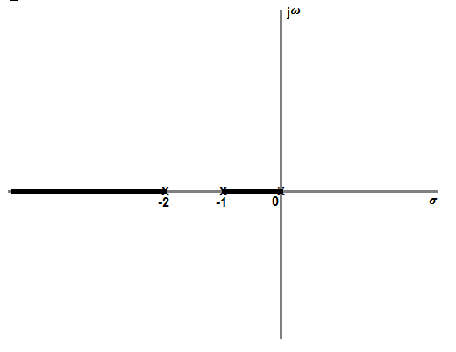Ex. → No.1 is 0 No.2 is -1 No.3 is -2

∴ segments lie to the left of 0→-1 & -2→ $∞$

1. Notes:
2. Number of separate loci = Number of open loop poles.
3. Number of loci → $∞$ = Number of open loop poles- Number of open loop zeros ${ n}_{p}-{ n}_{z}$.
4. The root loci must be symmetrical with the horizontal real axe.
5. The loci → $∞$ along linear asymptotes.
6. Determine the asymptotes which are centered at $σ_{A}$ with angels ${ φ}_{A}$.

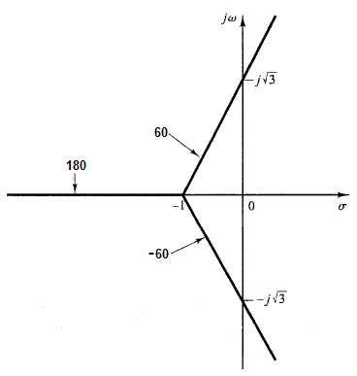 ${ σ}_{A}=\frac{\sum_{j=1}^{n}{(-P_{j})}-\sum_{i=1}^{M}{(-Z_{i}})}{{ n}_{p}-{ n}_{z}}$ ${ φ}_{A}=\frac{(2q+1)}{{ n}_{p}-{ n}_{z}}180°$, q =0, 1, 2, … (${ n}_{p}-{ n}_{z}-1$)

Ex. → ${ σ}_{A}=\frac{0-1-2}{3}=-1$ ${ φ}_{A}=\frac{(2q+1)}{3}180°$, q =0, 1, 2 → ${ φ}_{A}=±60, 180$

1. Determine the point at which the loci cross the imaginary axis using
2. Routh's Criterion → the roots of the auxiliary equation.

Ex. → $q\left(s\right)=s^{3}+{3s}^{2}+2s+k=0$ ${ s}^{3} 1 2$

$s^{2} 3 k$

$s^{1} \frac{6-k}{3}$

$s^{0} k$

Auxiliary polynomial $P\left(s\right)={3s}^{2}+k$& $k=6$ ∴ $P\left(s\right)={3s}^{2}+6$ $s=±j\sqrt{2}$

1. Characteristics Equation → the roots for s= j $ω$.

Ex. → $q\left(jω\right)={(jω)}^{3}+{3(jω)}^{2}+2(jω)+k=0$ → $\left(k-3ω^{2}\right)+j(2ω-ω^{3})=0$

$\left(k-3ω^{2}\right)=0 j(2ω-ω^{3})=0$

For $k=0 ω=0, k=6 ω=±j\sqrt{2}$

Note that: $ω=±j\sqrt{2}$ for the loci crossing but $s=±j\sqrt{3}$ for the asymptotes crossing

1. Determine the breakaway point on the real axis by solving the roots for $\frac{dK}{ds}=0$

Ex. → $q\left(s\right)=s^{3}+{3s}^{2}+2s+k=0$ → $K=-(s^{3}+{3s}^{2}+2s)$ → $\frac{dK}{ds}=-({3s}^{2}+6s+2)$

∴ $s=-0.4226 , s=-1.5774$ doesn't on the root loci

∴ the breakaway point is $s=-0.4226$

1. 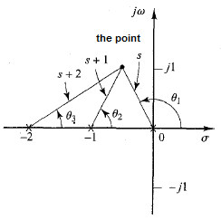Use the magnitude condition to find the gain $\dot{K }$ at a specified root |

Ex. → At s=-0.3337 $±$ j0.578 $| \frac{K }{S\left(S+1\right)\left(S+2\right)}|_{s=-0.3337± j0.578 }=1$ → K=1.0383

Note that to determine the location of s at which k=6 $| \frac{K }{\dot{s }\left(\dot{s }+1\right)\left(\dot{s }+2\right)}|_{K=6}=1$

→ $s^{3}+{3s}^{2}+2s+6=0$

$s=±j\sqrt{2}, s=-3$ similarly the 3rd pole at which K=1.0383 is $s=-2.3326$

The value of K corresponding to any point s on a root locus can be obtained usingthe magnitude condition, or graphically by

K = $\frac{product of lengths between point s to poles}{product of lengths between point s to zeros}$

1. Use the angle condition to prove that a point is on the root locus : $∠\left[H\left(s\right)G\left(s\right)\right] =±180°\left(2k+1\right) \left(k=0,1,2,………\right)$

$∠\left[\frac{K }{S\left(S+1\right)\left(S+2\right)}\right]=±180°\left(2k+1\right)$ $-\left[∠\left(S\right)+∠\left(S+1\right)+∠\left(S+1\right)\right]= -\left[∠θ_{1}+∠θ_{2}+∠θ_{3}\right]=-180°$

1. For complex-conjugate open-loop poles determine the angle of departure from $\left[∠Zeros-∠Poles\right]=-180°$

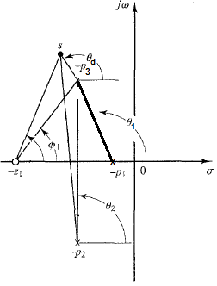 $\left[φ_{1}-θ_{d}-θ_{1}-θ_{2}\right]=-180°$ as $φ_{1}$ angle of the first zero $θ_{1}$ angle of one pole on the real axis

$θ_{d}$ angle of departure of one of the two complex-conjugate poles

 $θ_{2}$ angle of the second pole of the two complex-conjugate poles

1. Draw the root loci



EXAMIPLE 2 sketch the root-locus plot of a system shown

Solution:

The characteristics equation is $1+K\frac{\left(S+2\right)}{S^{2}+2S+3}=0$

Poles are $s=-1±j\sqrt{2}$ Zero is $s=-2$

The segments of the real axis that are root loci lies to the left of -2→ $∞$

Number of separate loci = 2. Number of loci → $∞$ = 1

There is one asymptote at ${ σ}_{A}=0$ ${ φ}_{A}=180°$

The breakaway point on the real $\frac{dK}{ds}=0$

 ∴ $s=-3.732 , s=-0.268$ doesn't on the root loci ∴ the breakaway point is $s=-3.732$

The angle of departure $θ_{d}=145°$

To show the occurrence of a circular root locus in the present system, we need to derive the equation for the root locus. For the present system, the angle condition is

$$\left[∠\left(S+2\right)-∠\left(S+1+j\sqrt{2} \right)-∠\left(S+1-j\sqrt{2} \right)\right]= -180°$$

If $s=σ+jω$ is substituted into this last equation, we obtain $$\left[∠\left(σ+jω+2\right)-∠\left(σ+jω+1+j\sqrt{2} \right)-∠\left(σ+jω+1-j\sqrt{2} \right)\right]= -180°$$

$\tan^{-1}{( \frac{ω+\sqrt{2}}{σ+1} )}{+tan}^{-1}{(\frac{ω-\sqrt{2}}{σ+1} )}=\tan^{-1}{( \frac{ω}{σ+2} )}+180°$

Taking tangents of both sides of this last equation using the relations hip $\tan\left(x±y\right)=\frac{\tan\left(x\right)±\tan\left(y\right)}{1∓\tan\left(x\right)\tan\left(y\right)}$

we obtain $\frac{\frac{ω+\sqrt{2}}{σ+1}+\frac{ω-\sqrt{2}}{σ+1}}{1-\frac{ω+\sqrt{2}}{σ+1} \frac{ω-\sqrt{2}}{σ+1}}=\frac{\frac{ω}{σ+2}+0}{1-\frac{ω}{} X 0}$ ∴ $ω\left[{\left(σ+2\right)}^{2}+ω^{2}-3\right]=0$

$ω=0$ ${\left(σ+2\right)}^{2}+ω^{2}= {\sqrt{3}}^{2}$

These two equations are the equations for the root loci for the present system. Notice that the first equation, $ω=0$ is the equation for the real axis. The second equation for the root locus is an equation of a circle with center at $σ=-2$, $ω=0$ and the radius equal to $\sqrt{3}$

Note that equations for the root locus can be derived for simple systems only.

Comments on the Root-Locus Plots.

For $H\left(s\right)G\left(s\right)=K\frac{ \left(S+z_{1}\right)\left(S+z_{2}\right)……..\left(S+z_{n}\right)}{\left(S+p_{1}\right)\left(S+p_{2}\right)…….\left(S+p_{m}\right)} , m>n$

If m – n $≥$ 2 , then the coefficient $p_{1}$ is the negative sum of the roots of the equation and is independent of K. In such a case, if some of the roots move on the locus toward the left as K is increased, then the other roots must move toward the right as K is increased

Also noted that a slight change in the pole-zero configuration may cause significant changes in the root-locus configurations.



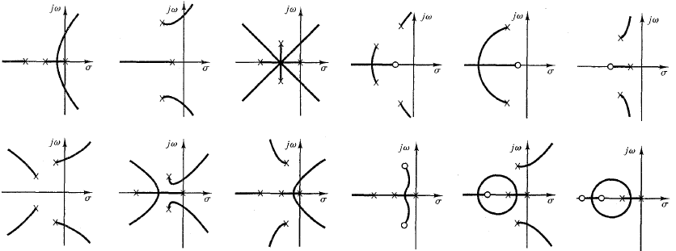

State Variable:

1. State Equation $X^{∙}=AX+BR$
2. Output Equation $C =DX+ER$
3. State Transmission Matrix $ϕ(s) ={\left(SI-A\right)}^{-1} φ(t) =L^{-1}[{(SI-A)]}^{-1}$
4. Transfer Function $TF=D{\left(SI-A\right)}^{-1} B+E$
5. Characteristics Equation $Q\left(s\right)=\left|SI-A\right|=0$

Where: A, B, D, E are coefficient matrices and

R is vector of inputs

C is vector of outputs

X is vector of state variables $x\left(t\right)=φ\left(t\right)X\left(0\right)+L^{-1}[{\left(SI-A\right)}^{-1} BR\left(s\right)]$

Note that:

The state equation and the output equation are known as dynamic equation.

I is the identity matrix $I=\left[\begin{matrix}1 & 0 & 0 \\ 0 & 1 & 0 \\ 0 & 0 & 1\end{matrix}\right]$

The inverse of a matrix $Inverse= \frac{Adjacent}{Determinant}$

$\left[\begin{matrix}1 & 2 \\ 3 & 4\end{matrix}\right]$ → Determinant $=4-6$

→ Adjacent $\left[\begin{matrix} 4 & -2 \\ -3 & 1\end{matrix}\right]$ ∴ ${\left[\begin{matrix}1 & 2 \\ 3 & 4\end{matrix}\right]}^{-1}=\frac{1}{4-6}\left[\begin{matrix} 4 & -2 \\ -3 & 1\end{matrix}\right]$ $\left[\begin{matrix}3 & 2 & 5 \\ 8 & 1 & 7 \\ 9 & 4 & 6\end{matrix}\right]$
 → Determinant $=\left(3\left[\left(1x6\right)-\left(4x7\right)\right]\right)+\left(8\left[\left(2x6\right)-\left(4x5\right)\right]\right)+(9\left[\left(2x7\right)-\left(1x5\right)\right])$

→ Transpose $=\left[\begin{matrix}3 & 8 & 9 \\ 2 & 1 & 4 \\ 5 & 7 & 6\end{matrix}\right]$

→ Adjacent $=\left[\begin{matrix} \left[\left(1x6\right)-\left(4x7\right)\right] & -\left[\left(2x6\right)-\left(4x5\right)\right] & \left[\left(2x7\right)-\left(1x5\right)\right] \\ -\left[\left(8x6\right)-\left(9x7\right)\right] & \left[\left(3x6\right)-\left(9x5\right)\right] & -\left[\left(3x7\right)-\left(8x5\right)\right] \\ \left[\left(8x4\right)-\left(9x1\right)\right] & -\left[\left(3x4\right)-\left(9x2\right)\right] & \left[\left(3x1\right)-\left(8x2\right)\right]\end{matrix}\right]$

Example 1 Determine the transfer function using S.F.G

$$\left[\begin{matrix}X_{1}^{∙} \\ X_{2}^{∙} \\ X_{3}^{∙}\end{matrix}\right]=\left[\begin{matrix}0 & 1 & -1 \\ 0 & -2 & 1 \\ 0 & 2 & -3\end{matrix}\right]\left[\begin{matrix}X_{1} \\ X_{2} \\ X_{3}\end{matrix}\right]+\left[\begin{matrix}0 \\ 2 \\ 1\end{matrix}\right]u$$

$$y= \left[\begin{matrix}1 & 1 & 0\end{matrix}\right]\left[\begin{matrix}X_{1} \\ X_{2} \\ X_{3}\end{matrix}\right]+ \left[\begin{matrix}0 \\ 0 \\ 0\end{matrix}\right]u$$

Solution:

$$X_{1}^{∙}{=X}_{2}-X_{3}$$

$$X_{2}^{∙}{=-2X}_{2}+X_{3}+2u$$

$$X_{3}^{∙}{=2X}_{2}-3X_{3}+u$$

$$y{=X}_{1}+X_{2}$$

State Diagram:

$L_{1}={-3s}^{-1}$

$$L_{2}={-2s}^{-1}$$

$$L_{3}={2s}^{-2}$$

$P_{1}=s^{-3}$ $∆_{1}=1$

$P_{2}={-s}^{-2}$ $∆_{2}=1-L_{2}$

$P_{3}=s^{-2}$ $∆_{3}=1$

$P_{4}={2s}^{-2}$ $∆_{4}=1-L_{1}$

$$P_{5}={2s}^{-1}{ ∆}_{5}=1-L_{1}$$

$$∆=1-\left(L_{1}+L_{2}+L_{3}\right)+{L_{1}L}_{2}$$

$$\frac{Y(s)}{U(s)}=\sum{\frac{P_{i}∆_{i}}{∆}}$$

Example 2:

$∅\left(s\right)=\frac{1}{s^{2}+7s+10}\left[\begin{matrix}s+4 & 1 \\ 2 & s+3\end{matrix}\right]$, $B=\left[\begin{matrix}0 \\ 2\end{matrix}\right]$

Find

1. Matrix A
2. $x_{2}(t)$ if $r\left(t\right)=5$ and all initial values = 0

Solution

$$ϕ(s) ={\left(SI-A\right)}^{-1} φ(t) =L^{-1}[{(SI-A)]}^{-1}$$

$${ϕ\left(s\right)=\left(SI-A\right)}^{-1}=\frac{Adj \left(SI-A\right)}{Det \left(SI-A\right)}$$

$$Adj \left(SI-A\right)= ϕ\left(s\right) Det \left(SI-A\right)$$

$$\left(SI-A\right)=\left[\begin{matrix}s+3 & -1 \\ -2 & s+4\end{matrix}\right]$$

$\left[\begin{matrix}s & 0 \\ 0 & s\end{matrix}\right]-A=\left[\begin{matrix}s+3 & -1 \\ -2 & s+4\end{matrix}\right]$

$A=\left[\begin{matrix}s & 0 \\ 0 & s\end{matrix}\right]-\left[\begin{matrix}s+3 & -1 \\ -2 & s+4\end{matrix}\right]$

$$A=\left[\begin{matrix}-3 & 1 \\ 2 & -4\end{matrix}\right]$$

$$x\left(t\right)=φ\left(t\right)X\left(0\right)+L^{-1}[{\left(SI-A\right)}^{-1} BR\left(s\right)]$$

$$\left[\begin{matrix}x_{1}(t) \\ x_{2}(t)\end{matrix}\right]=φ\left(t\right)\left[\begin{matrix}X_{1}(0) \\ X_{2}(0)\end{matrix}\right]+L^{-1}\left\{\frac{1}{(s+2)(s+5)}\left[\begin{matrix}s+4 & 1 \\ 2 & s+3\end{matrix}\right]\left[\begin{matrix}0 \\ 2\end{matrix}\right]\frac{5}{s}\right\}$$

$$x_{2}\left(t\right)=L^{-1}\left\{\frac{2(s+3)}{(s+2)(s+5)}\frac{5}{s}\right\}=L^{-1}\left\{\frac{A}{s}+\frac{B}{(s+2)}+\frac{C}{(s+5)}\right\}$$

$$x_{2}\left(t\right)=A+Be^{-2t}+Ce^{-5t}$$

$$x_{2}\left(∞\right)=A$$

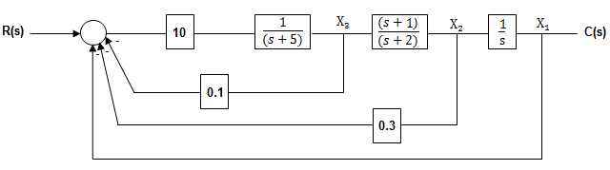Example 3:

Consider the shown system:

Find

1. Dynamic equation
2. Transfer function

Solution:

From the block diagram:

$$X_{1}=\frac{1}{s} ∴X_{1}^{∙}=X_{2}$$

$$X_{2}=\frac{s+1}{s+2}X_{3} ∴X_{2}^{∙}+2X_{2}=X_{3}^{∙}+ ∴X_{2}^{∙}=X_{3}^{∙}+X_{3}-2X_{2}$$

$$X_{3}=\frac{10}{s+5}[R\left(s\right)-0.1X_{3}-0.3X_{2}-X_{1} ∴X_{3}^{∙}+5X_{3}=-10X_{1}-3X_{2}-X_{3}+10R\left(s\right) ∴X_{3}^{∙}=-10X_{1}-3X_{2}-6X_{3}+10R\left(s\right)$$

$∴X_{2}^{∙}=-10X_{1}-5X_{2}-5X_{3}+10R\left(s\right)$

$$C=X_{1}$$

$\left[\begin{matrix}X_{1}^{∙} \\ X_{2}^{∙} \\ X_{3}^{∙}\end{matrix}\right]=\left[\begin{matrix}0 & 1 & 0 \\ -10 & -5 & -5 \\ -10 & -3 & -6\end{matrix}\right]\left[\begin{matrix}X_{1} \\ X_{2} \\ X_{3}\end{matrix}\right]+\left[\begin{matrix}0 \\ 10 \\ 10\end{matrix}\right]R(s)$

Dynamic Equation

$C= \left[\begin{matrix}1 & 0 & 0\end{matrix}\right]\left[\begin{matrix}X_{1} \\ X_{2} \\ X_{3}\end{matrix}\right]+ \left[\begin{matrix}0 \\ 0 \\ 0\end{matrix}\right]R(s)$

$$SI-A=\left[\begin{matrix}s & 0 & 0 \\ 0 & s & 0 \\ 0 & 0 & s\end{matrix}\right]-\left[\begin{matrix}0 & 1 & 0 \\ -10 & -5 & -5 \\ -10 & -3 & -6\end{matrix}\right]=\left[\begin{matrix}s & -1 & 0 \\ 10 & s+5 & 5 \\ 10 & 3 & s+6\end{matrix}\right]$$

$\left[\begin{matrix}s & -1 & 0 \\ 10 & s+5 & 5 \\ 10 & 3 & s+6\end{matrix}\right]$ → Determinant $=s\left[\left(s+5\right)x\left(s+6\right)-15\right]-10\left[-1x(s+6)\right]+10\left[-1x5\right]=s^{3}+11s^{2}+25s+10$

→ Transpose $=\left[\begin{matrix}s & 10 & 10 \\ -1 & s+5 & 3 \\ 0 & 5 & s+6\end{matrix}\right]$

→ Adjacent $=\left[⋯\right]$

→ Adjacent $=\left[\begin{matrix} \left(s+5\right)x\left(s+6\right)-15 & (s+6) & -5 \\ ⋯ & ⋯ & ⋯ \\ ⋯ & ⋯ & ⋯\end{matrix}\right]$

$$TF=D{\left(SI-A\right)}^{-1} B+E= \frac{1}{s^{3}+11s^{2}+25s+10}\left[\begin{matrix}1 & 0 & 0\end{matrix}\right]\left[\begin{matrix} s^{2}+11s+15 & (s+6) & -5 \\ ⋯ & ⋯ & ⋯ \\ ⋯ & ⋯ & ⋯\end{matrix}\right]\left[\begin{matrix}0 \\ 10 \\ 10\end{matrix}\right]$$

$$TF= \frac{1}{s^{3}+11s^{2}+25s+10}\left[\begin{matrix}s^{2}+11s+15 & (s+6) & -5\end{matrix}\right]\left[\begin{matrix}0 \\ 10 \\ 10\end{matrix}\right]=\frac{10\left(s+6\right)-50}{s^{3}+11s^{2}+25s+10}=\frac{10s+10}{s^{3}+11s^{2}+25s+10}$$